# Design Documentation

Building on the documentation basics from Lesson 1, this guide explores how to craft professional documentation that will enhance your portfolio.

## Taking Your Documentation Skills Further

Now that you've grasped the documentation fundamentals, let's examine how to create portfolio-worthy materials that showcase both your technical abilities and design sensibility.

## Documentation for Portfolio Development

### 1. Capturing Temporal Qualities

Interior spaces transform dramatically throughout the day and across seasons. As designers, we need to record these subtle yet important shifts to truly understand how our designs function in real-world contexts.

* Shoot the same view at different times to reveal lighting variations
* Note how materials appear different as light conditions shift
* Watch how spatial perception changes depending on natural light direction

**[Figure Fig 1: No suitable image found]**

[Image: A series of three photographs showing the same interior space at different times of day - morning, midday, and evening - demonstrating how natural light dramatically transforms the perception of colors, textures, and spatial qualities. Caption: "Fig 1: Light study documentation showing how the same space transforms throughout the day, affecting material appearance and spatial perception."]

### 2. Creating Complete Documentation Sets

When preparing portfolio materials, keep in mind that individual documentation elements should work together to tell a cohesive story about the space. This integrated approach demonstrates your ability to think holistically about design.

* Match technical drawings with photographic documentation
* Develop materials that highlight both technical expertise and aesthetic judgment
* Keep a consistent visual language throughout your documentation set

### 3. Sophisticated Documentation Methods

As you grow more comfortable with basic documentation, you'll want to incorporate more nuanced approaches that unveil deeper insights about your designs. These refined techniques can set your portfolio apart by highlighting your analytical thinking and eye for detail.

* Material studies with lighting analysis
* Circulation maps showing how people move through spaces
* Perspective drawings emphasizing key design features
* Before/after documentation showing transformation potential

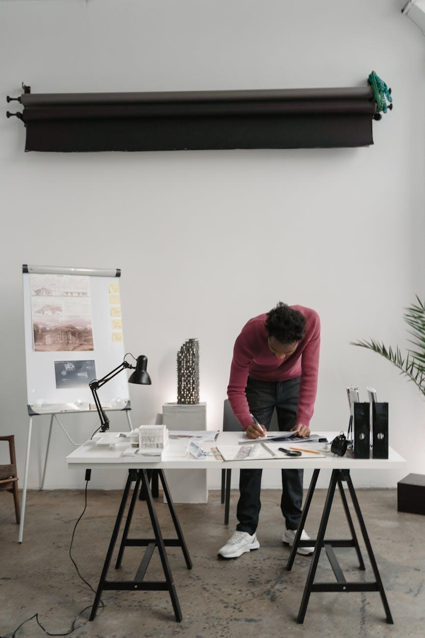

Fig.2 (Tima Miroshnichenko on [Pexels](https://www.pexels.com/photo/6615224/), 2025) Example of a thorough documentation set that tells a complete story about a design project through multiple documentation methods.

### 4. Professional Presentation Strategies

Your documentation is only as effective as how you present it. Even the most detailed measurements and stunning photographs need thoughtful organization to communicate clearly with clients, contractors, and potential employers.

* Organize documentation logically to tell a spatial story
* Use consistent formatting and labeling throughout
* Include brief notes explaining key features or decisions
* Consider how digital and physical documentation complement each other

## Portfolio Integration

Your documentation doesn't just record spaces—it showcases your professional abilities and design process. When selecting which documentation to include in your portfolio, think carefully about what each piece reveals about your skills and approach to design challenges.

* Select 3-5 of your strongest documentation examples for your portfolio
* Arrange documentation to show your methodical approach
* Use documentation to support your design narratives
* Include documentation that highlights your attention to detail

**Try This when analyzing different interior environments:** How might you document different types of spaces? Think about how you'd adjust your approach when documenting a residential kitchen versus a commercial lobby, and what unique qualities of each you'd want to highlight. Write down the top three documentation priorities for each space type.

## Professional Application

The documentation skills you're developing aren't just classroom exercises—they're vital tools you'll use throughout your career. Understanding their real-world value helps you see beyond this course.

* They'll help you communicate clearly with clients and contractors
* They showcase your technical skills to potential employers
* They allow you to track design decisions and project development
* They build the foundation for more complex documentation in future projects

The documentation techniques you're learning now directly translate to what you'll need in entry-level positions, making you more competitive in the job market.

If you tackle this documentation exercise, we'd love to see what you create in the online forum discussion. This hands-on experience will prepare you for upcoming projects and portfolio development.

## Equipping You for HNC Success

These documentation skills form the technical foundation for your HNC studies, enabling you to communicate design concepts professionally while developing your unique creative voice.